**Lab08 Repeating Decimals**

**The Problem**

The decimal expansion of the fraction 1/33 is tex2html_wrap_inline43, where the tex2html_wrap_inline45 is used to indicate that the cycle 03 repeats indefinitely with no intervening digits. In fact, the decimal expansion of every rational number (fraction) has a repeating cycle as opposed to decimal expansions of irrational numbers, which have no such repeating cycles.

Examples of decimal expansions of rational numbers and their repeating cycles are shown below. Here, we use parentheses to enclose the repeating cycle rather than place a bar over the cycle for the ease of typing.

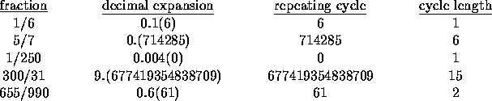

**Program Development**

Write a program that reads numerators and denominators of fractions and determines their repeating cycles. A repeating cycle of a fraction is the first minimal length string of digits to the right of the decimal that repeats indefinitely with no intervening digits. Thus for example, the repeating cycle of the fraction 1/250 is 0, which begins at position 4 (as opposed to 0 which begins at positions 1 or 2 and as opposed to 00 which begins at positions 1 or 4).

**Input**

A line with 2 integers: an integer numerator, which is nonnegative, followed by an integer denominator, which is positive. None of the input integers exceeds 3000.

**Output**

Print the cycle and the length of the cycle.

**Sample Input**

76 25

**Sample Output**

76/25 has a cycle (0) of length 1

**Submission**

Zip the complete package that includes the solution folder of all the source files and the testHarness.txt file, the in folder of all test data, and the out folder the set of the output data, name it***Lab08g<YourLabGroupNo><YourMatricNo>.zip****.* Submit the zip file into the correct folder in your group’s workbin.